**WEEK 8**

**GIT-1**

Familiar with Git commands like git init, git status, git add, git commit, git push, and git pull.

Step1: Setting up my Machine with Git Configuration

a) Checking if Git is Installed

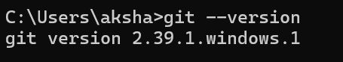

b) Configuring Git User Info



c) Verifying the Configuration

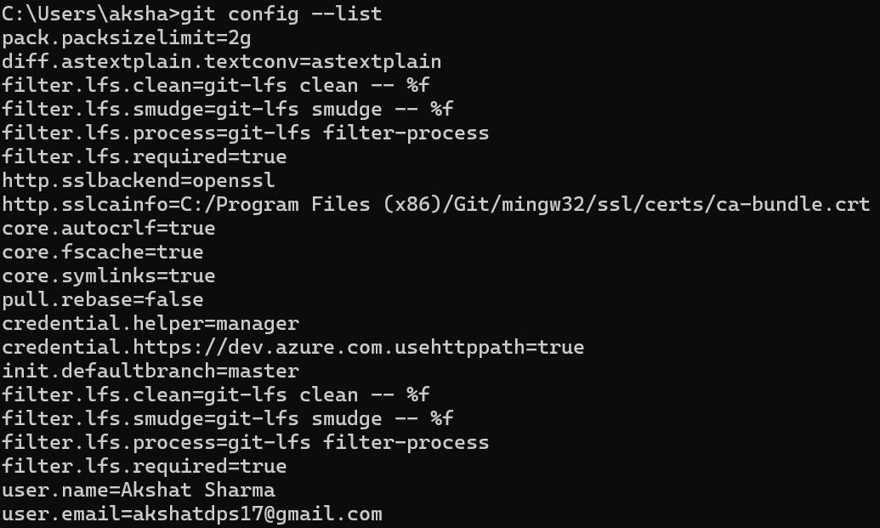

Step2: Integrating Notepad++ as Default Git Editor

a)Checking if Notepad++ Works in Git Bash

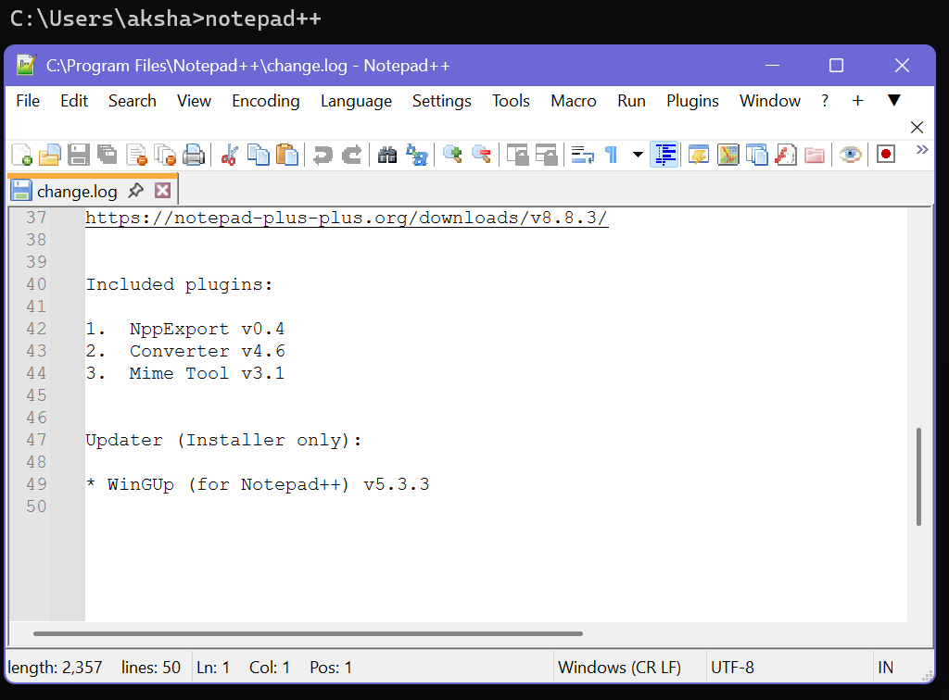

b) Set Notepad++ as Git's Default Editor



c) Verifying Editor Configuration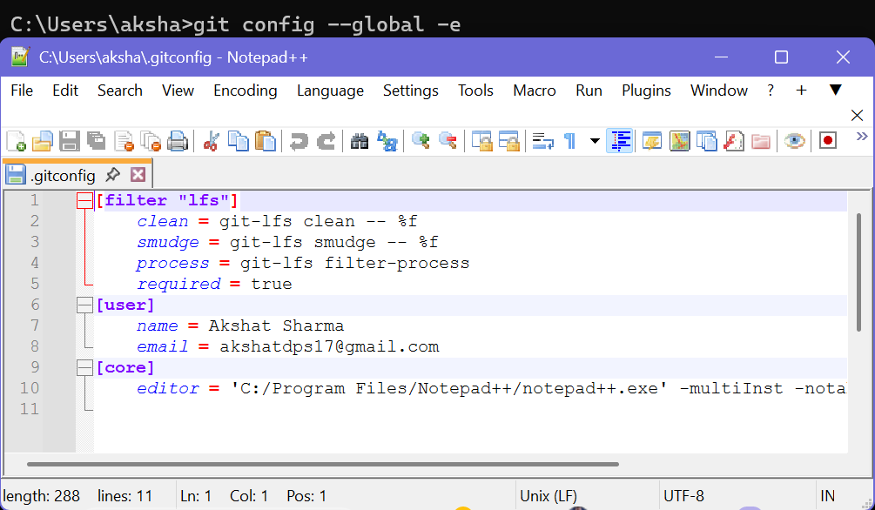

Step3: Adding a File to Source Code Repository

a)Initializing a Git Repository

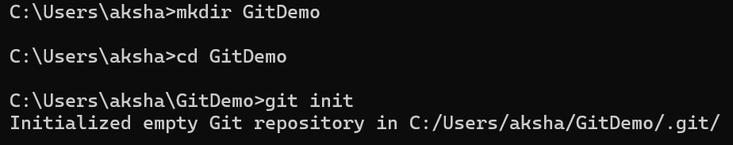

b) Creating a File



c)Check the file

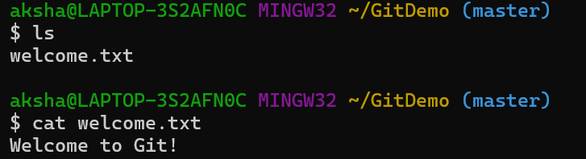

d)Checking git status

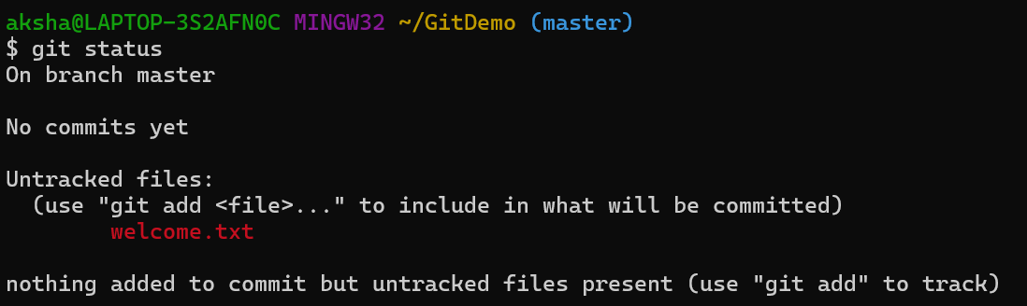

e)Tracking the file



f)Commiting the file with editor

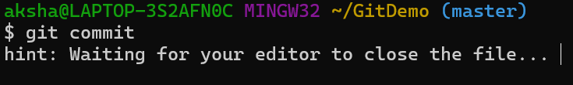

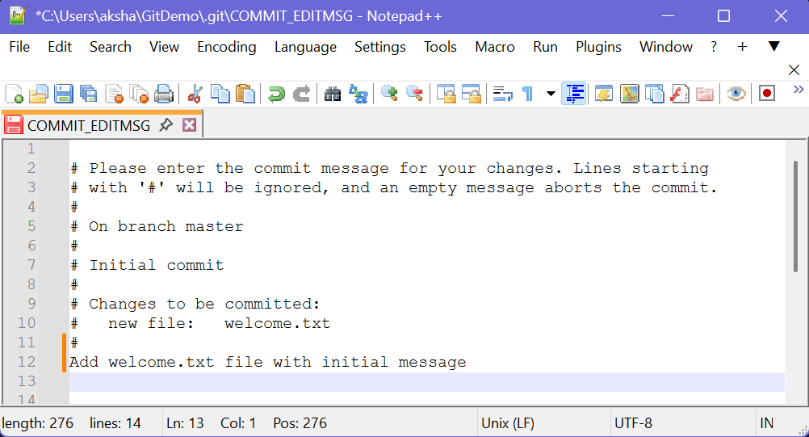

Step4: Pushing to Remote Repository (GitLab)

a) Creating a Remote Repository

-logging in GitLab

-Creating a new repository called GitDemo

b) Connecting Local to Remote



c) Pulling Latest



d) Pushing to Remote Repository

